AWS cloud: https://879381271968.signin.aws.amazon.com/console

Created the aws account.
Set I am user with MFA.
Created billing alarm using cloudwatch service.

Setting up EC2 machine:

- first added name and tags to my EC2 machine.
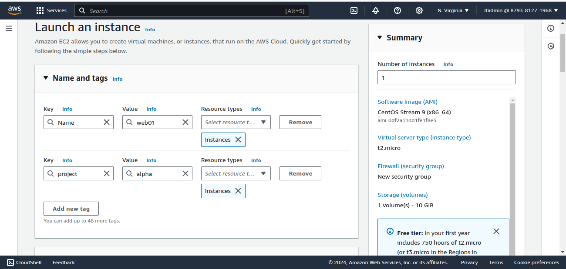
- The selected the AMI(amazon machine image) for my ec2 machine.
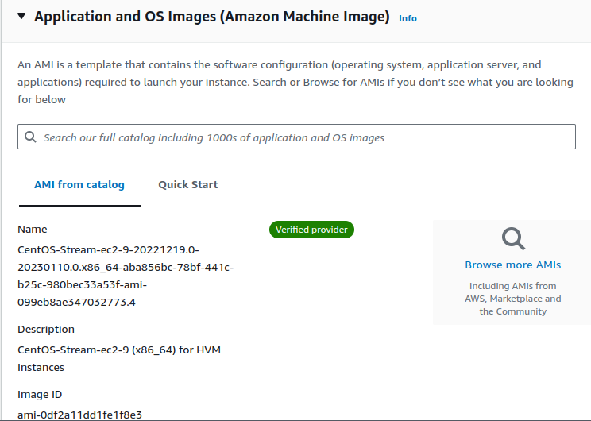
- Then selected the instance type – as t2.micro having 1 gb cpu and igb ram for free tier account.
- Now create the key pair.
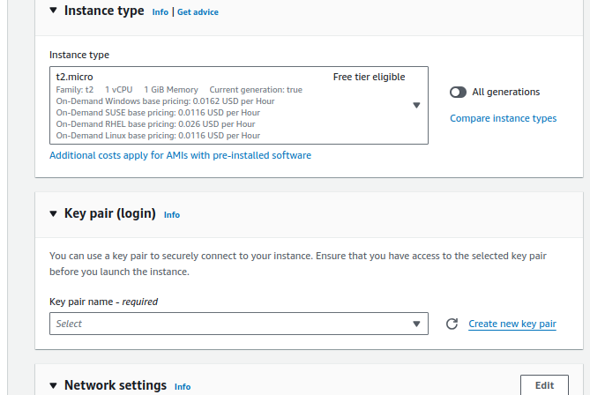
D
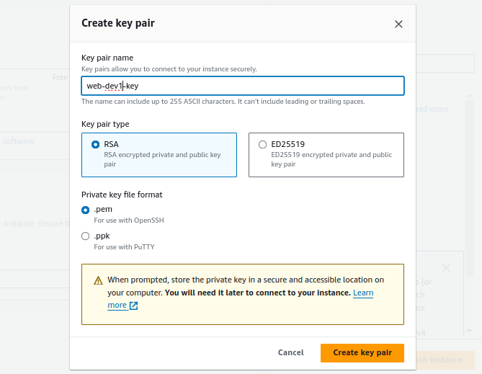

- Network settings – setup the firewall rule. Every EC machine will have a mandatory firewall rule – which is called security group
in this we gave few rules:
subnets – No preference . Using this it will automatically select the zone.
Configure storage – 10GB
type – ssh having port 22.
source type – my IP.
In the last under advance details give your linux commands like below, so that when your EC2 machine gets boot up. You get those services in your EC2 machine.
#!/bin/bash

sudo yum install httpd -y
sudo systemctl start httpd
sudo systemctl enable httpd
mkdir /tmp/test1

- And in the end click on launch instance.
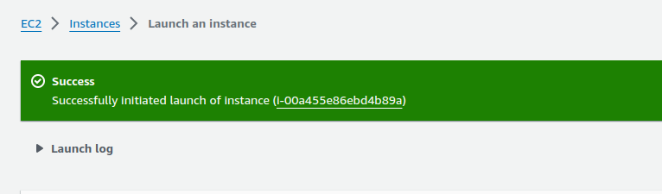

So firewall of above EC2 machine only allows port 22, but the service which we installed httpd runs on port no 80.
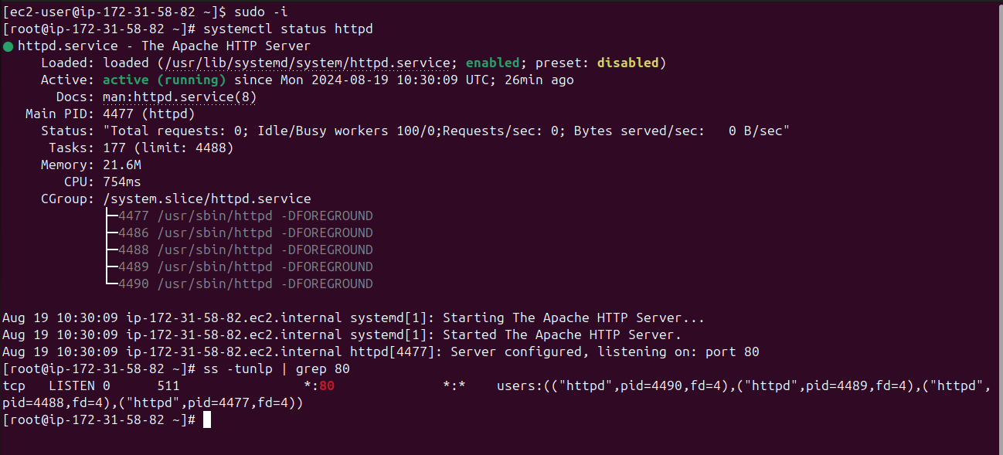
So now, we need to make changes in firewall(security groups) of our EC2 machine.
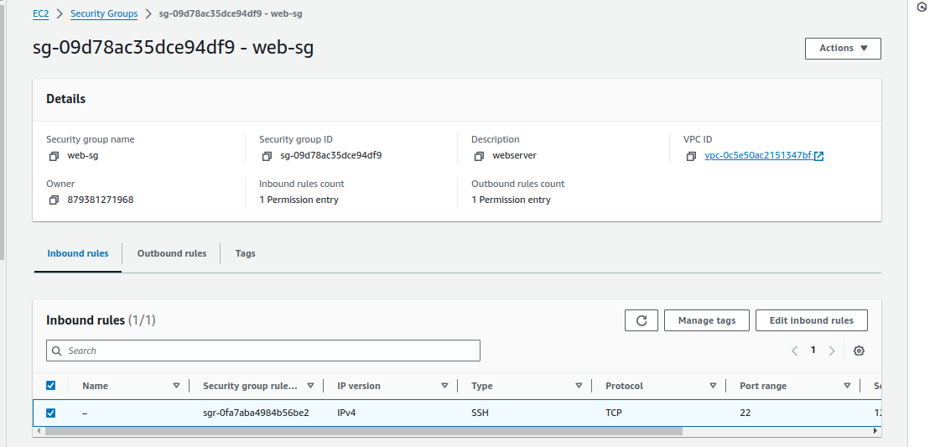
Here then edit the inbound rules and add the port no 80.

EC2 instance creation steps -

- Requirement gathering
OS → This will tell you which AMI to go with.
Size → Ram, CPU, Network etc. Based on these info. We will select the instance type.
Storage size
Project on which working on. → this will help us in deciding the tags
Services/Apps running → Like SSH,HTTP,MYSQL etc
Environment(Dev,QA,Staging,prod)
Login User/Owner → Who will use and who will be the owner.

- create the key pair → this we should do before we launch the instance and also make habit of creating separate key pair for each environment(development ,QA,prod).
- Then create the firewall(Security Group).
- Launch the Instance.
- When you stop an EC2 instance, your public IP lost, and you get a new one when you initiate the machine again.
- If you want your IP remain static even when you stop and restart the EC2 machine, then use Elastic Ips(By default we get 5 IP in EC2, we can ask for more from support) and then associate it with your EC2 machine.
- As we create a EC2 instance, few other things gets created. Like Network interface, Volumes(virtual hard disk) .
- Security groups, public IP all this is for this network interface, not for EC2 instance.

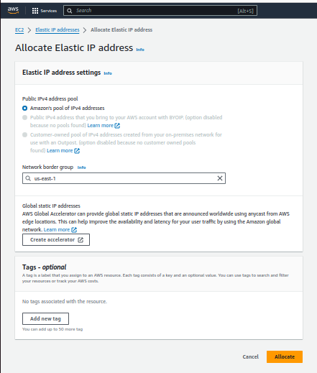

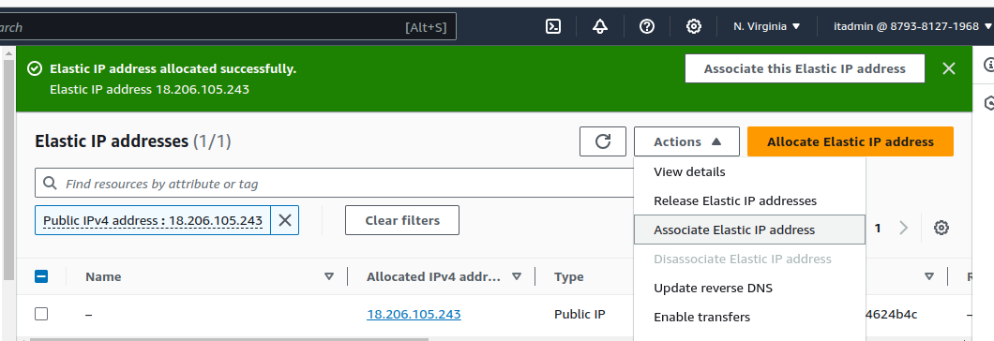

Security groups/firewall:
Inbound rule let say ssh: Means you are allowing anyone to connect via ssh on port no:22.

Two type of rules
- Inbound rule: Traffic coming from outside on the instance.
- Outbound rule: Traffic which is generating from the instance and going out. So, we can set what traffic can go out from the instance.

Setup of web server on ubuntu machine:
command:
sudo apt update
sudo apt install apache2 wget unzip -y
wget https://www.tooplate.com/zip-templates/2128_tween_agency.zip
unzip 2128_tween_agency.zip
cp -r 2128_tween_agency/* /var/www/html/ → We should always store our web pages at this location.
systemctl restart apache2

__________________________________________________________________________

Setting up AWS CLI :-
Installation:
- curl "https://awscli.amazonaws.com/awscli-exe-linux-x86_64.zip" -o "awscliv2.zip"
- unzip awscliv2.zip
- sudo ./aws/install
Setting up:
- Go to IAM users, and create a user for AWSCLI with administrator access.
- Then inside the AWSCLI user, go to security credentials, and in order to use CLI, we need access keys. So, click on create access keys.
- Note: Never reveal your access keys.
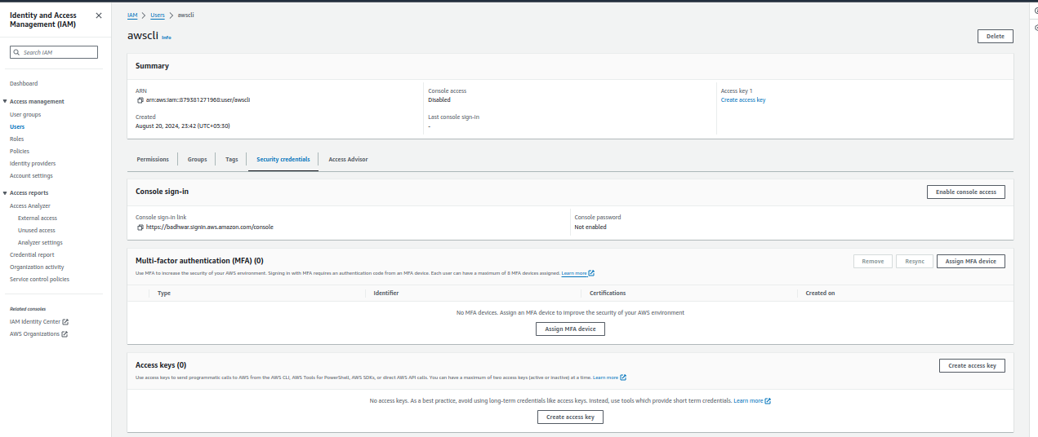
d
- Now type command: aws configure, to configure AWSCLI
- Then it will ask for access key id and then secret access key.
- Then it will ask for default region. I gave us-east-1
- Then default output format. I gave json.
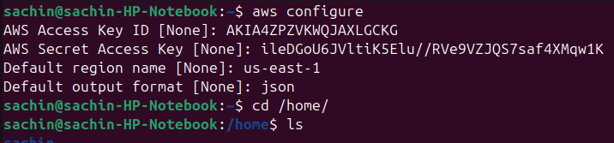

Now you can check in the home directory, folder as .aws
where all of the config details, which we gave above will be saved.
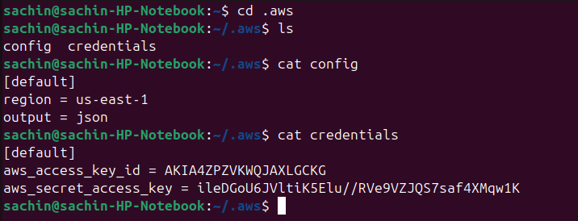
S
type command:
aws sts get-caller-identity
- It will give the user id of accound
- account
- and arn

aws ec2 describe-instances → this awscli command is for checking the ec2 instances.

We don’t need to remember the awscli commands, we can go to google search the command what we want to achieve.

EBS

Elastic Block Storage – This provides the EBS volume and it’s snapshot(backup).
- Block based storage.
- It uses EC2 instance, store data from db,file data etc.
- While creating the EBS volume, we specify the availability zone, and instance should also be in the same availability zone where we have our EBS volume.
- EBS data is automatically replicated within the availability zone, This is how we can protect our data from any upcoming failure.
- Snapshot is a backup of a volume.

EBS types:
- General purpose(SSD) - Used for most work load.

- Provisioned IOPS – This is used to run large databases, where we need good performance. I/O speed will be the more than the above general purpose type.
- Throughput optimized HD – mostly used in big-data and data warehouses.
- Cold HDD → Used for file servers. Very low cost.
- Magnetic → Used for backup and archives. Very cheap.

Now lets create a EC2 machine with general purpose EBS(default).
- yum install httpd wget unzip -y
- systemctl start httpd
- systemctl enable httpd
- cd /tmp/
- wget https://www.tooplate.com/zip-templates/2128_tween_agency.zip
- ls -l
- unzip -o 2128_tween_agency.zip
- cp -r 2128_tween_agency/* /var/www/html/
- systemctl restart httpd
- systemctl status httpd

Jenkins

Commands to setup jenkins:
1 sudo apt update
2 sudo apt install openjdk-11-jdk -y
3 wget -O /usr/share/keyrings/jenkins-keyring.asc https://pkg.jenkins.io/debian-stable/jenkins.io-2023.key
4 echo "deb [signed-by=/usr/share/keyrings/jenkins-keyring.asc]" https://pkg.jenkins.io/debian-stable binary/ | sudo tee /etc/apt/sources.list.d/jenkins.list > /dev/null
5 sudo apt update
6 sudo apt-get install jenkins -y
- Home directory of Jenkins - ls /var/lib/jenkins/
- There is a user, who runs jenkins service, name – jenkins
- Jenkins URL – publicIP:8080

Jenkins jobs
- Freestyle jobs
- Pipeline as a code
freestyle jobs:
- Graphical Jobs
- Learning, understanding and exploring Jenkins
- Not recommended in Real time now.
Pipeline As a code:
- Pipeline created in groovy language.
- Recommended now.

How to add jdk plugin:

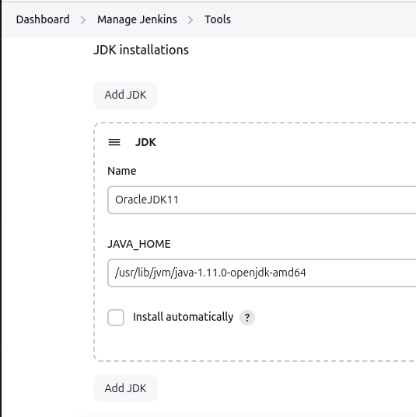

- path of java home we can get from the /usr/lib/jvm/java-1.11.0-openjdk-amd64

as

a

